# Compiling ASTM_2004

1. Download the source for ASTM_2004 from OSS Note 970603.
2. Acquire a license from FlowCal to use their QCI Header files.
3. In TestCases.c, the variable “main” is used. It is also used in astm_2004.c, creating a syntax error during compilation. To get around this issue, I renamed the variable “main1”.
   1. 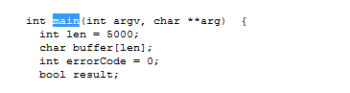
   2. 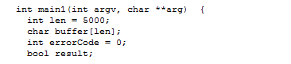
4. FTP everything to your server. The directory name is not important. You should have astm_2004.c and all of the FlowCal source in the same directory
5. The compile command below should be one continuous command line:
6. For LINUX Systems, use the following command to compile astm_2004:

**gcc -o astm_2004 astm_2004.c calculation.c calculationTest.c unit.c oilproducts.c quantity.c quantityTest.c TestCases.c util.c VBAExport.c calculationTest11_1_6_1.c calculationTest11_1_6_2.c calculationTest11_1_6_3.c calculationTest11_1_7_1.c calculationTest11_1_7_2.c calculationTest11_1_7_3.c -lm**

1. Install this in the SAP Kernel Directory, and give the directory name to your Functional RU Consultant so that they can update the path name in SPRO.